

On 11th December 2022

University of Rwanda

College of science and technology

School of ICT

Department of computer and software engineering

Level: 3

Course name: Software design and development lab

**PATNIZO Hotels Management system Project Report**

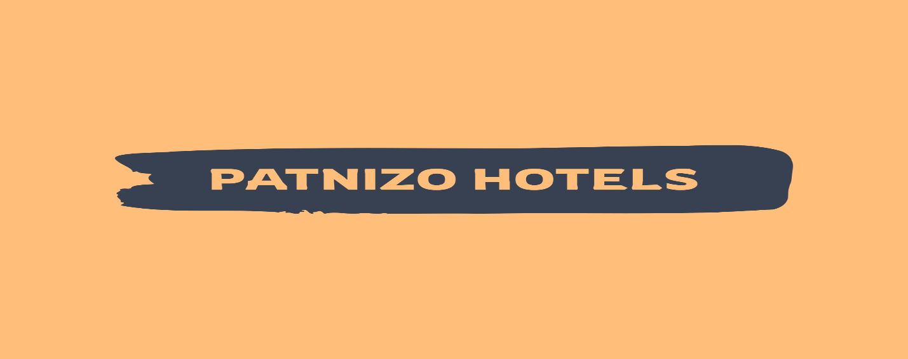

**Project Team and Contacts information:**

Names Reg-number Telephone

Niyogisubizo Thierry 220015546 0786802046

Uwimbabazi Aimee Patience 220005117 0789513895

Project team’s Email:

[niyaimee28@gmail.com](mailto:niyaimee28@gmail.com)

Project team’s Github:

<https://github.com/blessedones/Patnizo_Hotels/tree/master>

Let’s Start

**ACKNOWLEDGEMENT**

Apart from our efforts, the success of any project depends largely on the encouragement and guidelines of many others. We, Mr. Niyogisubizo Thierry and Mrs. Uwimbabazi Aimee Patience, we take this opportunity to express our gratitude to the people who have been instrumental in the ongoing successful completion of this project.

We would like to show our greatest appreciation to Mr. Eric Hitimana, Lecturer at university of Rwanda , department of Computer and software engineering, where we have learnt the basics of laravel web application framework and whose informal discussions and guidance becoming light for us in the entire duration of this work.

We can’t say thank you enough for their tremendous support and help, without their guidance this project would not have materialized.

Table of Contents

Contents

Chapter I: Introduction 5

1.1. Historical background of the case study 5

1.2 Introduction of Project 6

1.3. Problem Statement 6

1.4. Objectives 6

Chapter 2: System analysis and design 7

2.1. Functional requirements of project 7

2.1.1 Login Functionality 7

2.1.2 Intended users of the project 11

2.1.3 Intended system partners 11

2.2 system design 11

2.2.1 UI DESIGN (SKECTCH OF THE UI MODULE) 11

2.2.2. Database design and relationships 12

Chapter 3. Implementation 13

3.1. Introduction of the section 13

3.2 All screenshots of Patnizo Hotels system 14

3.3. Frontend side 14

**News & Events:** 22

3.4. Backend Side 23

Chapter 4. Conclusion 33

**Table of figures**

Figure 1-Admin login Functionality 8

Figure 2-worker login functionaity 9

Figure 3-customer login and register functionality 10

Figure 4-client register 11

Figure 5-patnizo hotels user interface design 12

Figure 6-database design and relationships 13

Figure 7-homepage1 15

Figure 8-hoempage2 15

Figure 9-homepage3 16

Figure 10-responsiveness1 17

Figure 11-responsiveness2 17

Figure 12-amenities1 18

Figure 13-amenities2 18

Figure 14-gallery1 19

Figure 15-gallery2 20

Figure 16-gallery 21

Figure 17-gallery4 22

Figure 18-updates and news 23

Figure 19-admin login 24

Figure 20-adminafterlogin 25

Figure 21-ourcustomers 25

Figure 22-registering a new customer 26

Figure 23-register notification 27

Figure 24-results of registration 27

Figure 25-viewing customer details 28

Figure 26-before updating 28

Figure 27-updating the field 29

Figure 28-updated notification 29

Figure 29-finally updated field 30

Figure 30-deleting customer 30

Figure 31-final deleted customer 31

Figure 32-payment fetching names due to relationship 31

Figure 33-our users 32

Figure 34-Roles 33

Figure 35-creating and eding roles 34

Figure 36-assigning Roles 35

Figure 37-Assigning permissions 36

# 

# Chapter I: Introduction

## 1.1. Historical background of the case study

Nowadays there is rapid development of infrastructures entire the world. Many people start their businesses and they grow day per day. It seems that one person may own two or more businesses or companies. Even government has many distributed companies but it is complicated to manage them. One platform is required to manage those companies.

By observation we have seen that, in Rwanda there is mismanagement of hotels that operates under single name. They have same purpose as they are owned by an individual but they do works in different ways as if they are not similar at all. From this there has been an idea of Patnizo Hotels.

Patnizo hotels is a multi-hotel management system that manages many different hotels starting from Patnizo Hotel as the main hotel, this project is all about of managing more than one hotel under the same control which Means there is many hotels that works under same rules, same style of working as well as same philosophy .

## 1.2 Introduction of Project

**Patnizo Hotels Management System** is a web application for managing various activities of the Hotels. This platform will help multi-hotel owner in management of all Hotels Information such as Clients, Hotels Activities, and Employees Management. It will also be like a heaven platform for clients as they will be able to access multiple hotels information at once, and it will assure clients that even if at different locations he will be going to receive same service as hotels will be working under same management, This project will be used by three main users which are Admin, Worker and a Customer.

Admin will be supreme user with all permissions to View items, manage items which include creating, editing and deleting items and lastly he also be able to manage other remaining users from his/her Admin dashboard. The worker is the user who works under the instructions of Admin, he will be able to View items, create new items but he won’t be able to edit or delete items and he won’t be able to manage remaining users which are customers. Customers or standard user will be able to only view items when asking for a service.

## 1.3. Problem Statement

From observation study, we found that there is very large scale of disorganization and miss Management in hotels which are owned by individuals , thereby we came with an idea of building a centralized platform for coordinating those different platforms, so they can be easily controlled and managed to achieve sameness and uniformity.

## 1.4. Objectives

After implementation of Patnizo Hotels Management System, we expect many different hotels management issues to be solved like:

* Centralized Maintenance of all our customers information
* Simplify work of management for hotels
* Coordinated hotels activities
* Uniformity and sameness of hotels

# Chapter 2: System analysis and design

## 2.1. Functional requirements of project

## 2.1.1 Login Functionality

## Admin

## When admin log in, he will be redirected to admin dashboard, he/she will be asked to enter Email and password, the system will check for entered credentials if they are wrong he will be notified and be asked to enter valid information, if they are right he/she will continue to admin page.

## Note: if the worker tries to enter as admin he will be told that he/she doesn’t have the right roles.

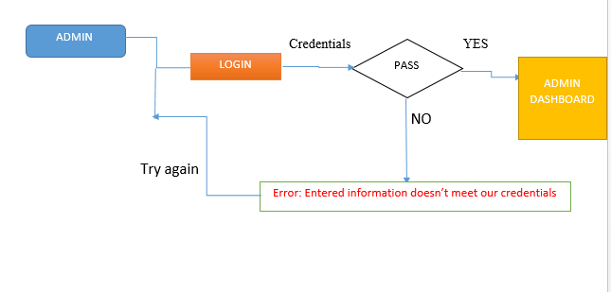

Figure 1-Admin login Functionality

**WORKER**

When a Worker log in, he will be redirected to worker dashboard, he/she will be asked to enter his/her Email and password, the system will check for entered credentials if they are wrong he will be notified and be asked to enter valid information, if they are right he/she will continue to workers page.

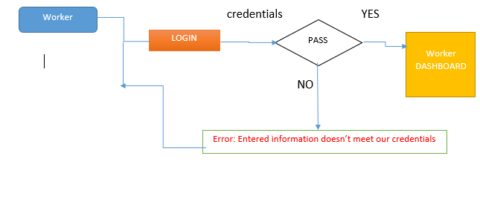

Figure 2-worker login functionality

­­­

Note: if the Admin tries to enter as a Worker he will be told that he/she doesn’t have the right roles.

Viewer (standard user or Customer)

When Viewer or customer logs in in, he will be redirected to user or customer portal , he/she will be asked to enter his/her email and password , the system will check the entered credentials if they are wrong he will be notified and be asked to enter valid information, if they are right he/she will continue to users portal where he/she can view services like booking or tour services and asks for them.

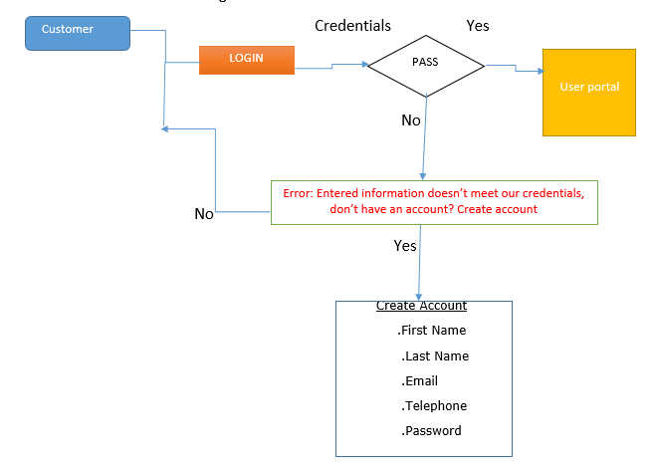

Figure 3-customer login and register functionality

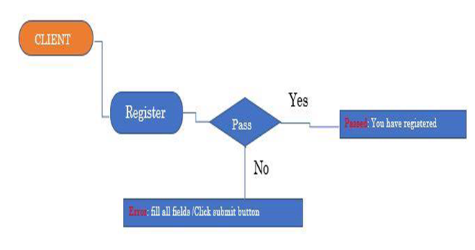

Figure 4-client register

­

## 2.1.2 Intended users of the project

* Multi-Hotel Owners
* Customers
* Government for meetings and Evaluation
* Job Seekers

## 2.1.3 Intended system partners

* Hotels
* Tourism industries
* Government of Rwanda

## 2.2 system design

## 2.2.1 UI DESIGN (SKECTCH OF THE UI MODULE)

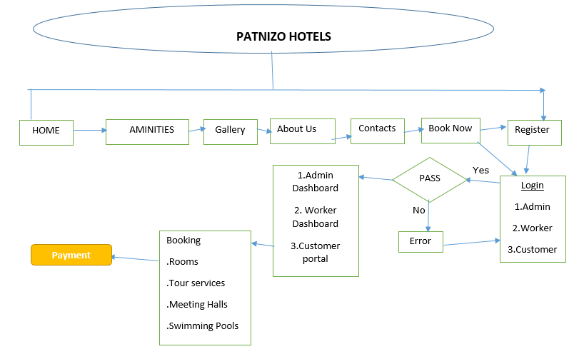

Figure 5-patnizo hotels user interface design

## 2.2.2. Database design and relationships

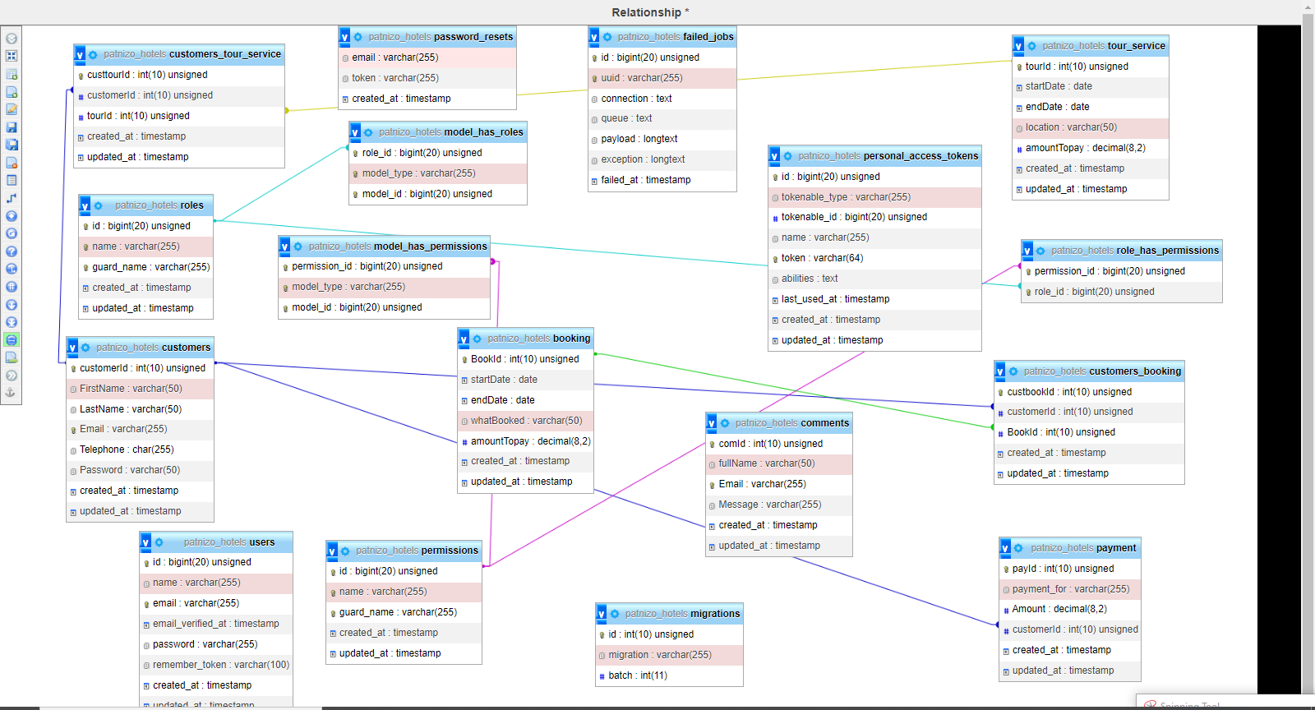

Figure 6-database design and relationships

# Chapter 3. Implementation

## 3.1. Introduction of the section

This section consists of an implementation plan of the project in implementation plan we will focus how the system will be working, in the next subchapter you will see the screen shoots of the pages of this project and explanation of the platform will work.

## 

## 3.2 All screenshots of Patnizo Hotels system

This part will show screenshots of all pages that are found in Patnizo Hotels Management system project and how every the operation performed step by step either on standard user (Customer side) or Admin and Worker side.

## 3.3. Frontend side

**Homepage View:**

Patnizo Hotels Homepage with photo sliding background, the homepage will be the primaly page that someone accesing the platform will come along, he will find links to other pages corresponding to the service he/she be wanting to access. Patnizo Hotels homepage has 3 sliding images with the same navigation bar , this will provide best user experience to the users that are accessing our system as an addition there is text explaining to the userwho we are and what he/she can expect from patnizo Hotels.

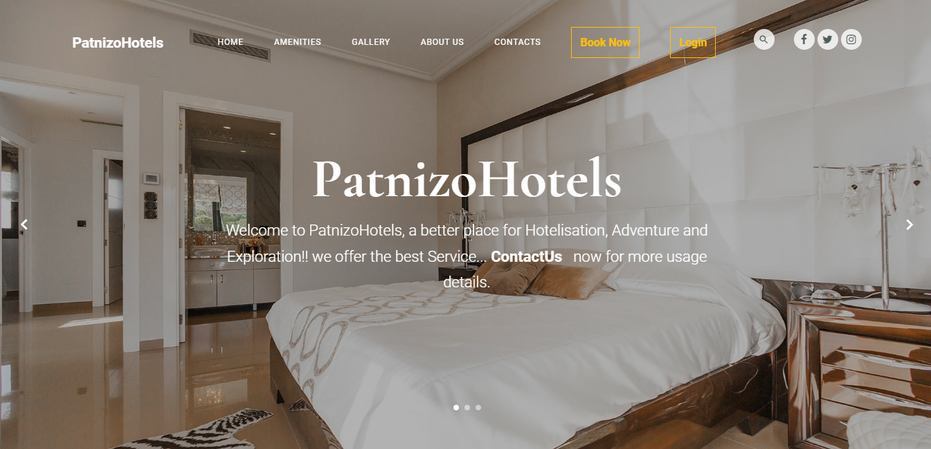

Figure 7-homepage1

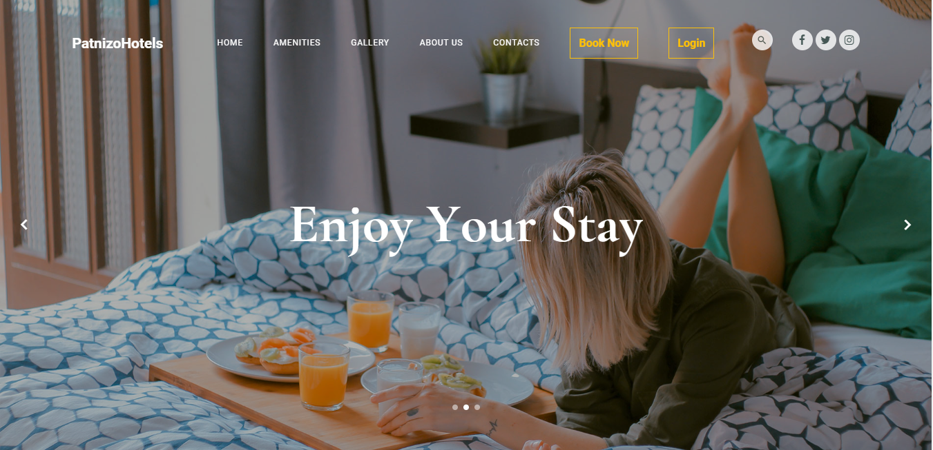

Figure 8-hoempage2

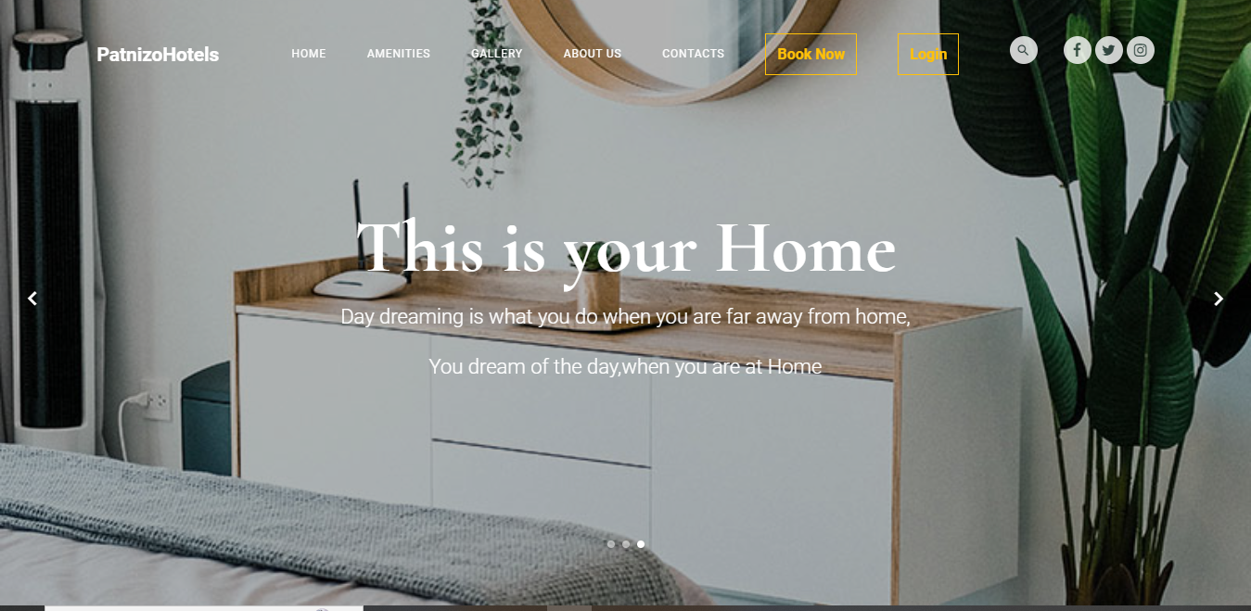

Figure 9-homepage3

***Patnizo Hotels is a responsive platform:***

Nowadays we need responsive web applications that are going to fit any client side screen, either when accessing the application using his/her Computer, Tablet or smartphone.

Thus, images below shows what happens when we small size our screen view,

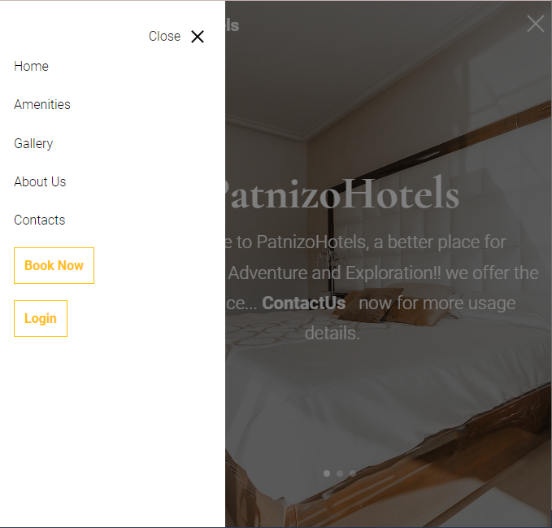

Figure 10-responsiveness1

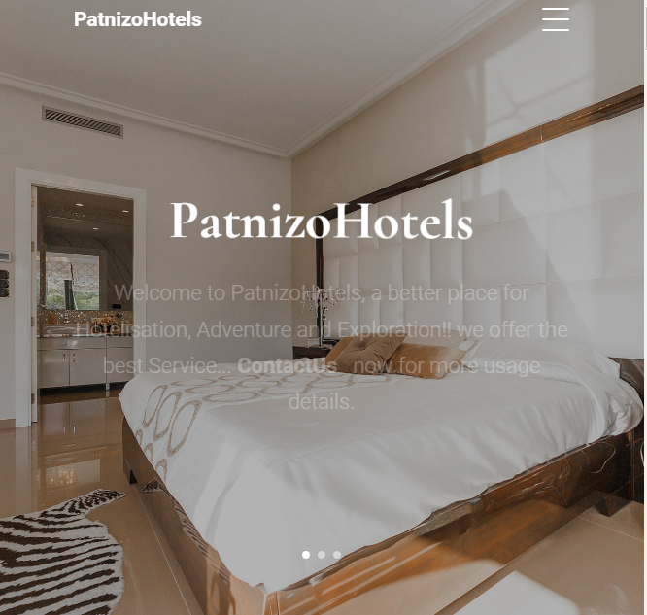

Figure 11-responsiveness2

***AMENITIES:***

Are desirable or useful feature in Patnizo Hotels that Customers may be interested about, Hotels has to have those services that may catch customers attention so they can fell proud and motivated to be our clients as well as to feel the need to work with us again.

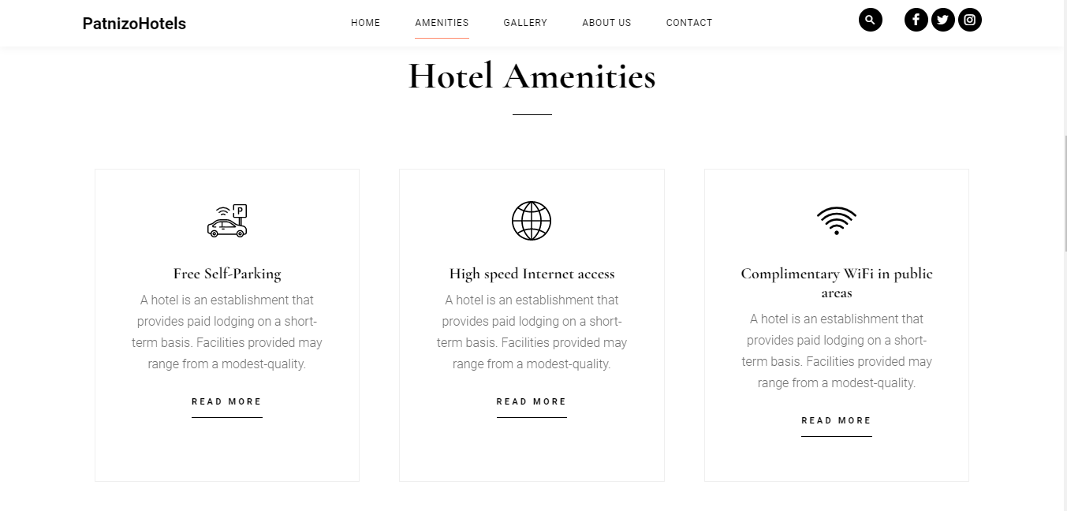

Figure 12-amenities1

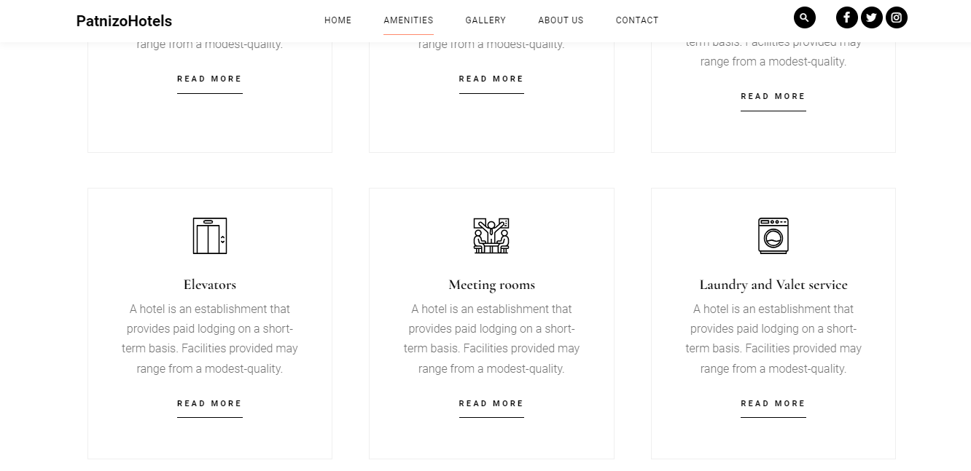

Figure 13-amenities2

**Gallery:**

Something shown remains in the mind but something said remains in the ears*, thus gallery is one of the most important part of any Hotel Platform, as it is where the Hotels showcase what they have got.*

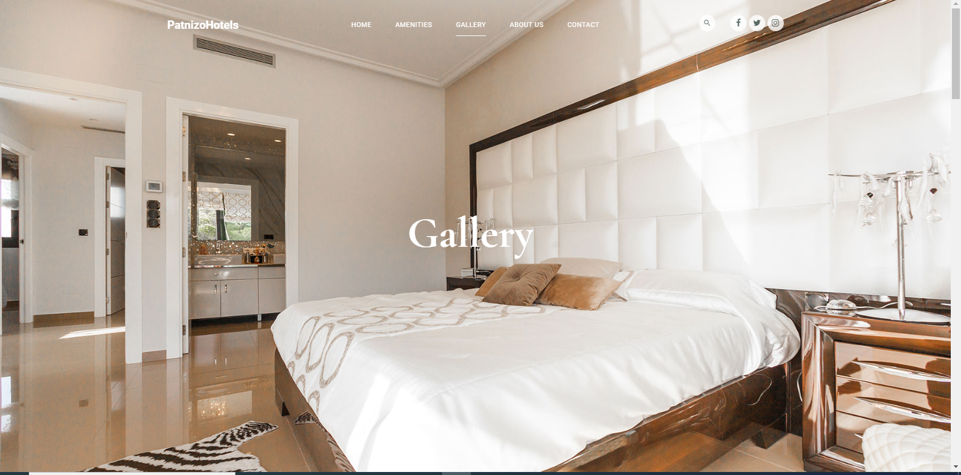

Figure 14-gallery1

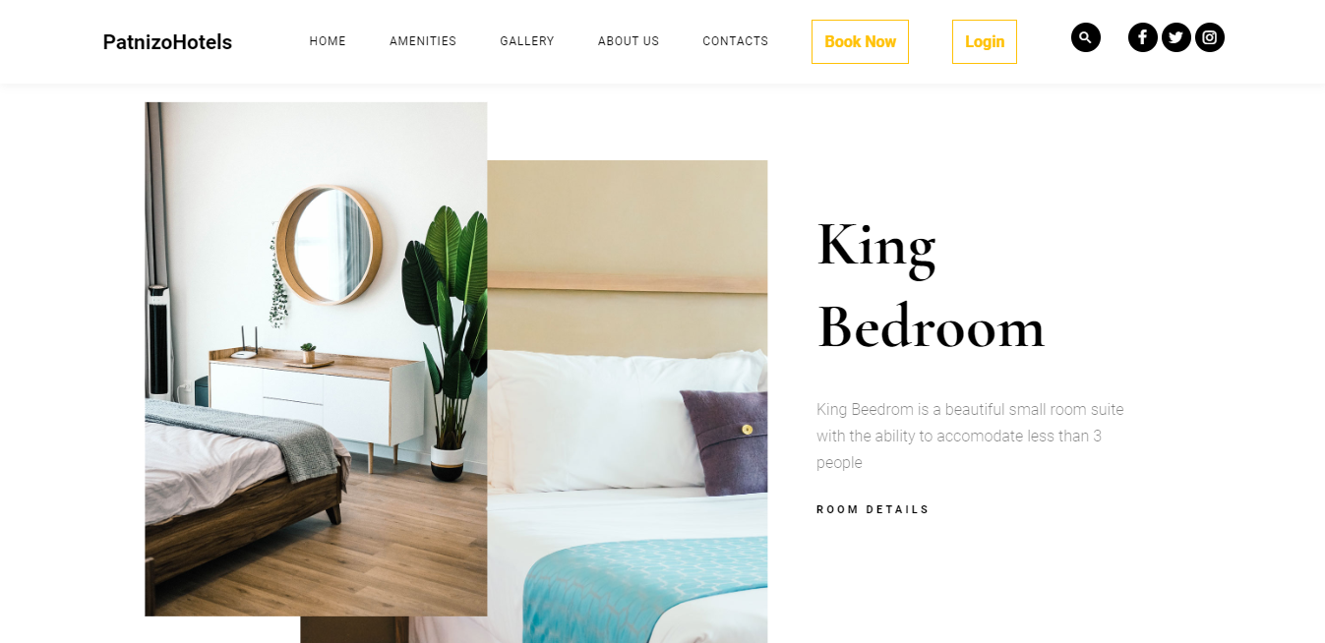

Figure 15-gallery2

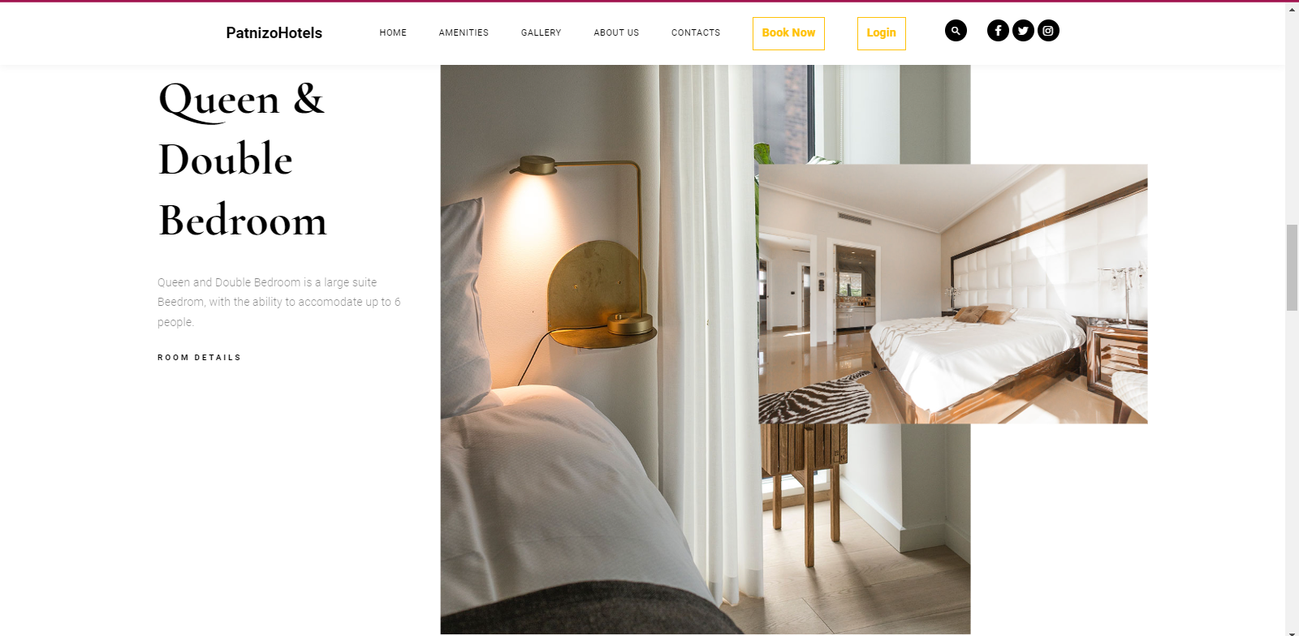

Figure 16-gallery

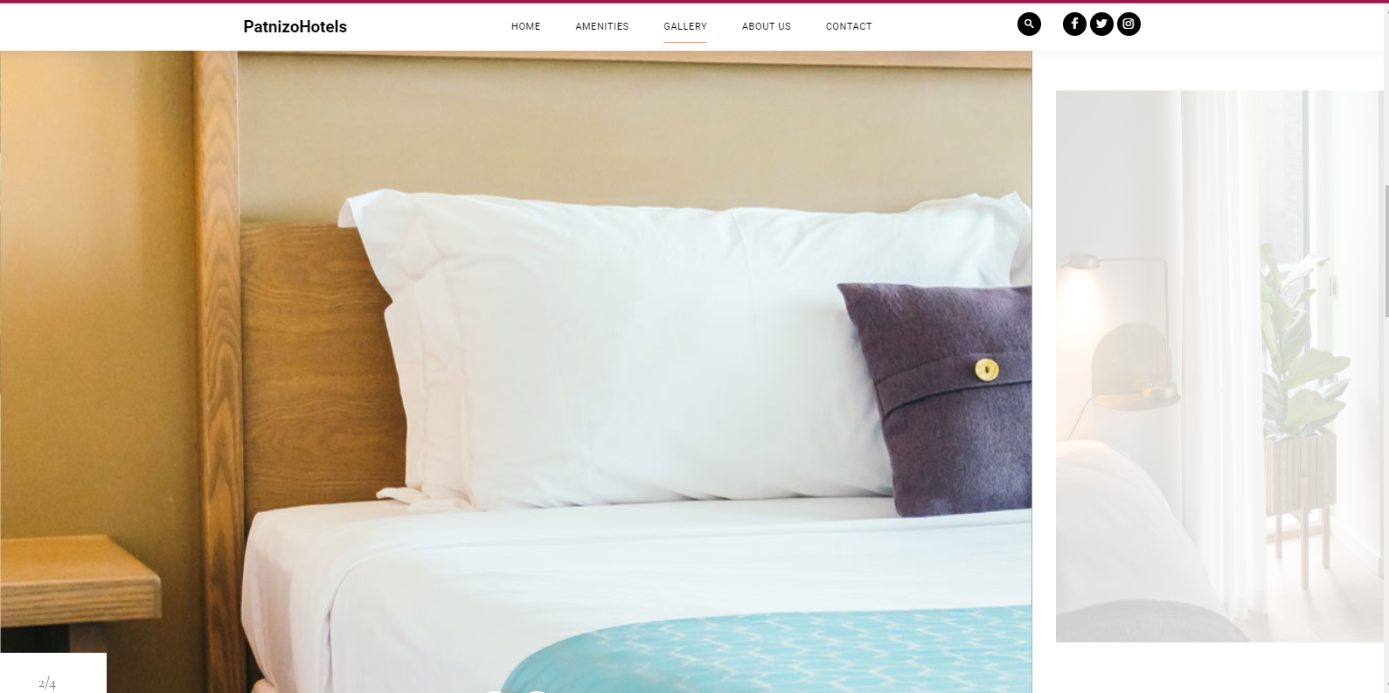

Figure 17-gallery4

### **News & Events:**

News &Events page will be accessed by scrolling down the homepage, it is going to help the customers to stay Updated to Hotel News. It’s not all about customers, this will be a good place where employees looking for jobs will check if there is any Job announcements at Patnizo Hotels.

The article will have the date of when it is posted and the names of someone giving that announcement just for clarity.

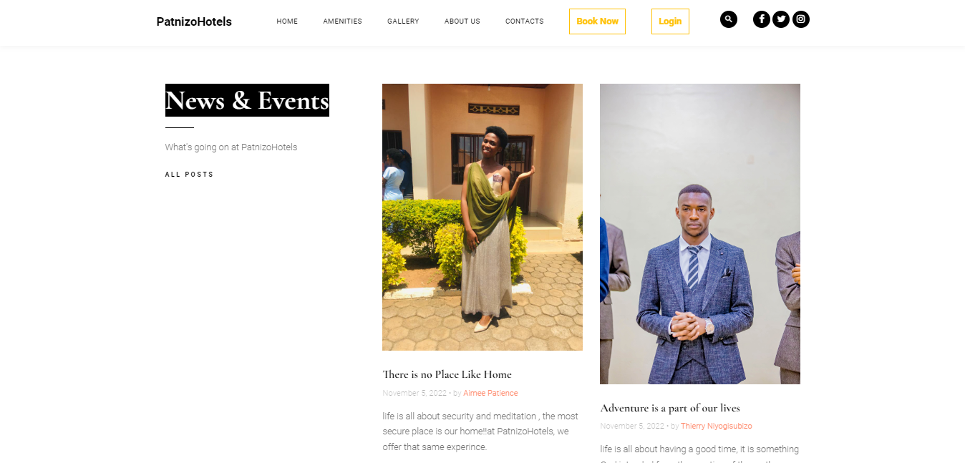

Figure 18-updates and news

## 3.4. Backend Side

***Logging in:***  lets now click on login button, the last link in our navigation bar, three users may login and based on their roles we have three users (Admin, Worker and Viewer or (customer)) they are going to be redirected to their respective pages, Admin will be redirected to Admin dashboard page, Worker will redirected to Worker page and Viewer (standard user or client) page. The credentials has to be valid if not, the one logging in will be notified and be asked to try again, and for the customer or viewer if he/she hasn’t registered he will be told to create an account.

1. **Logging in as Admin**

**Email:admin@gmail.com**

**Password: ‘’Call us for more info”**

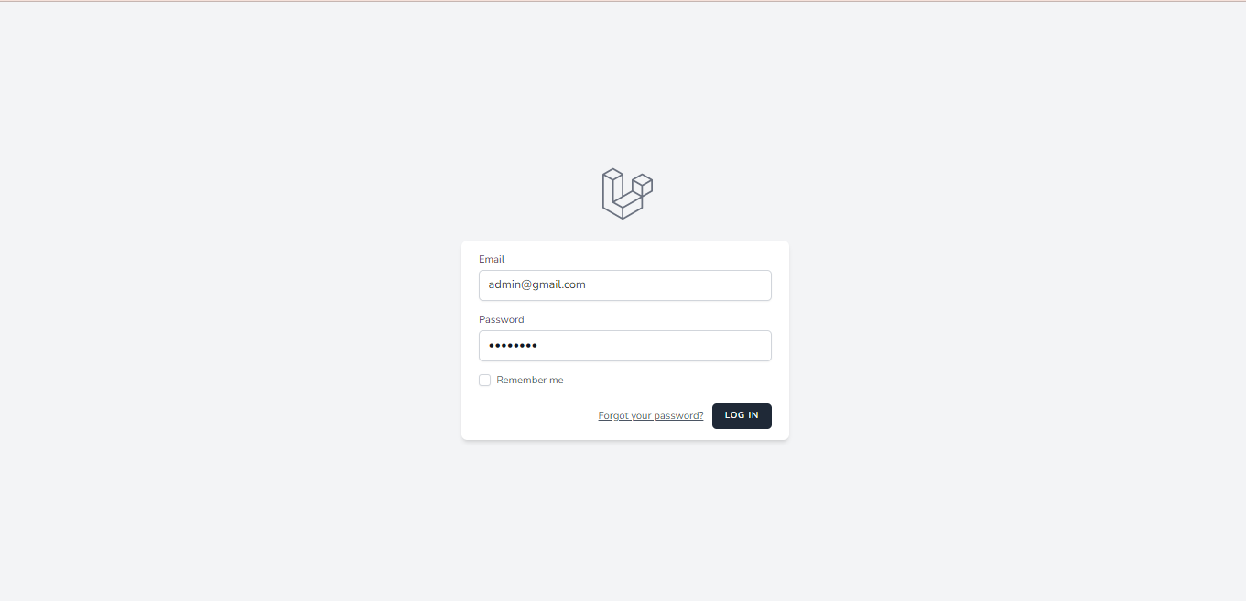

Figure 19-admin login

Admin after logging in:

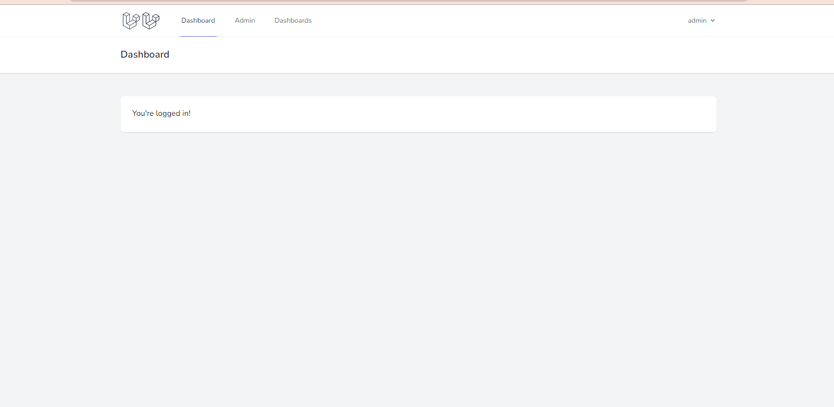

Figure 20-adminafterlogin

LET’S click Admin:

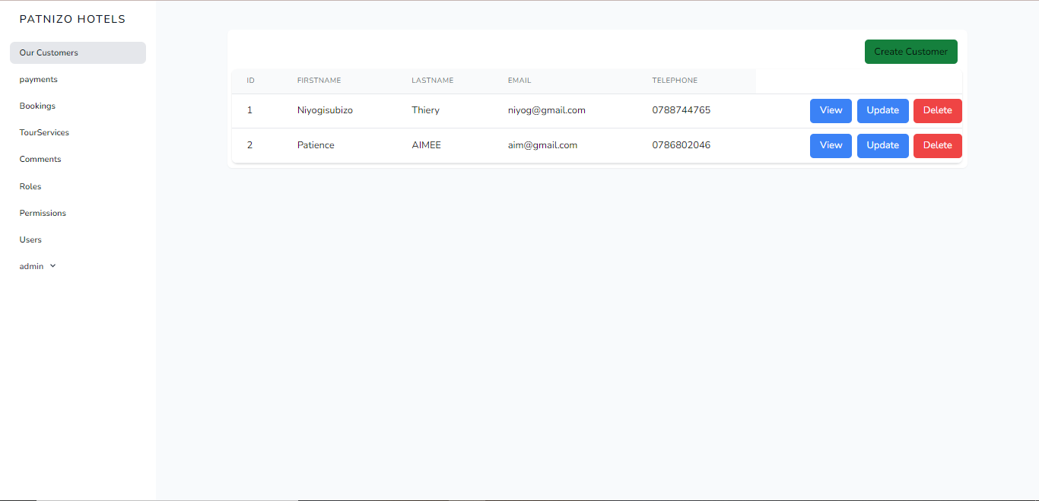

Figure 21-ourcustomers

From this we can see that admin can create, view, update and delete lets create a new customer:

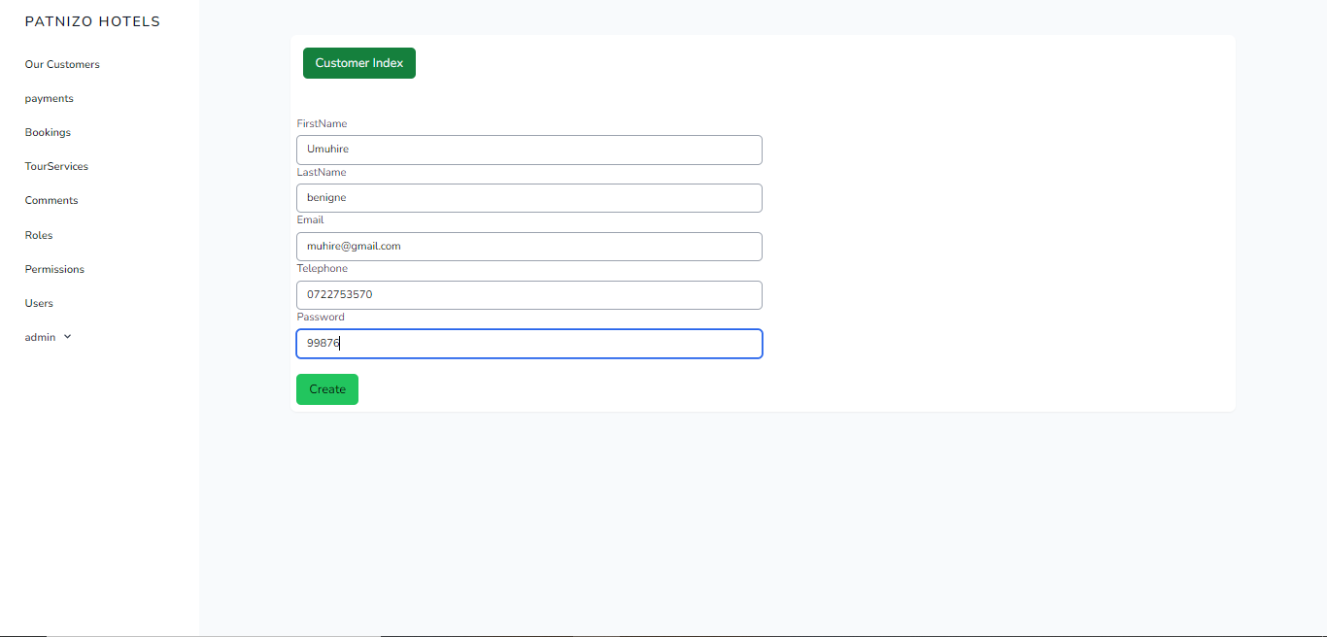

Figure 22-registering a new customer

Click create and after go to Customer Index:

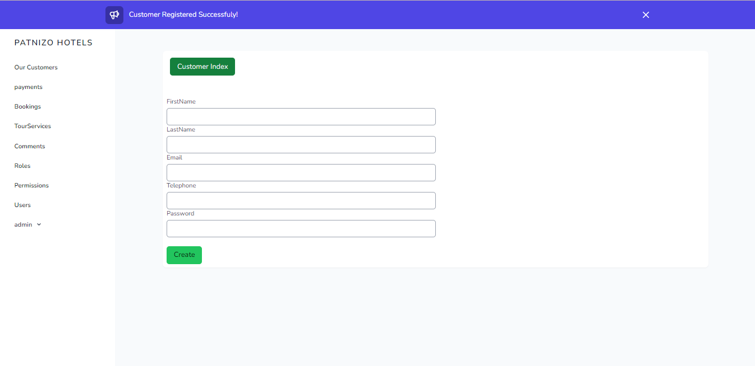

Figure 23-register notification

You will be notified that a new customer has been created. Now go to customer index to check

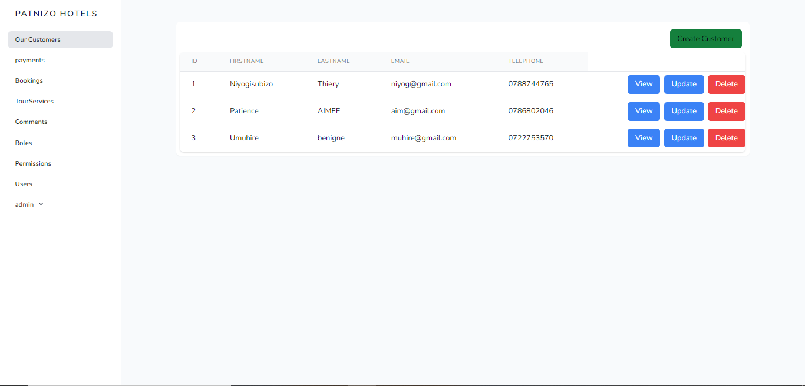

Figure 24-results of registration

Wow!! Here we go, new customer has registered lets proceed and View the details of a customer we have just created. Click View

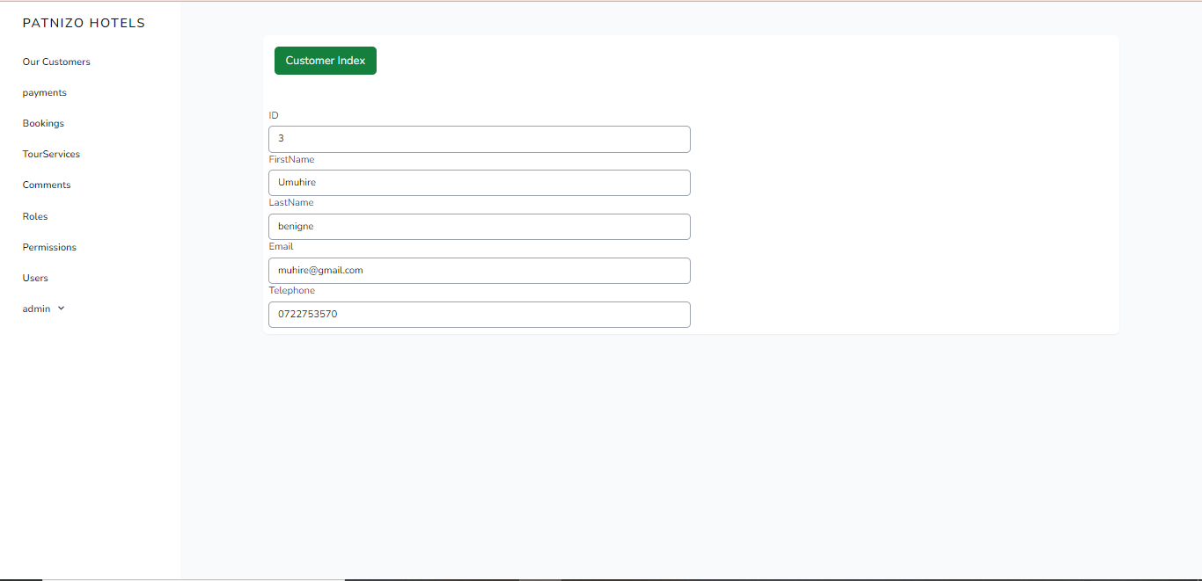

Figure 25-viewing customer details

This fields are un-editable, as we are just going to view.

**Update:**

Let’s update the customer (Niyogisubizo Thierry) and give him a long email

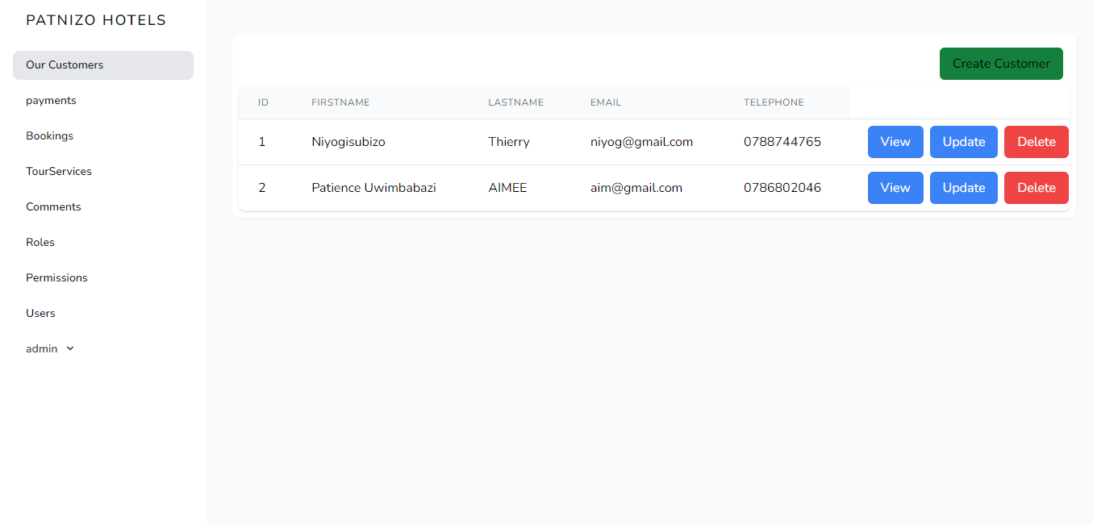

Figure 26-before updating

Go to update button and fill in a new email

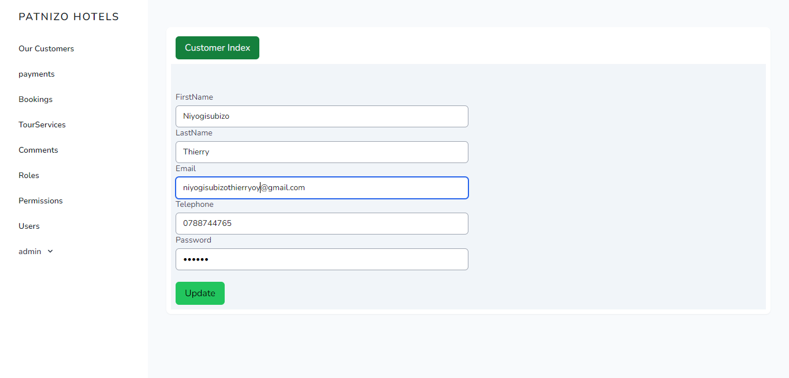

Figure 27-updating the field

Finally click update

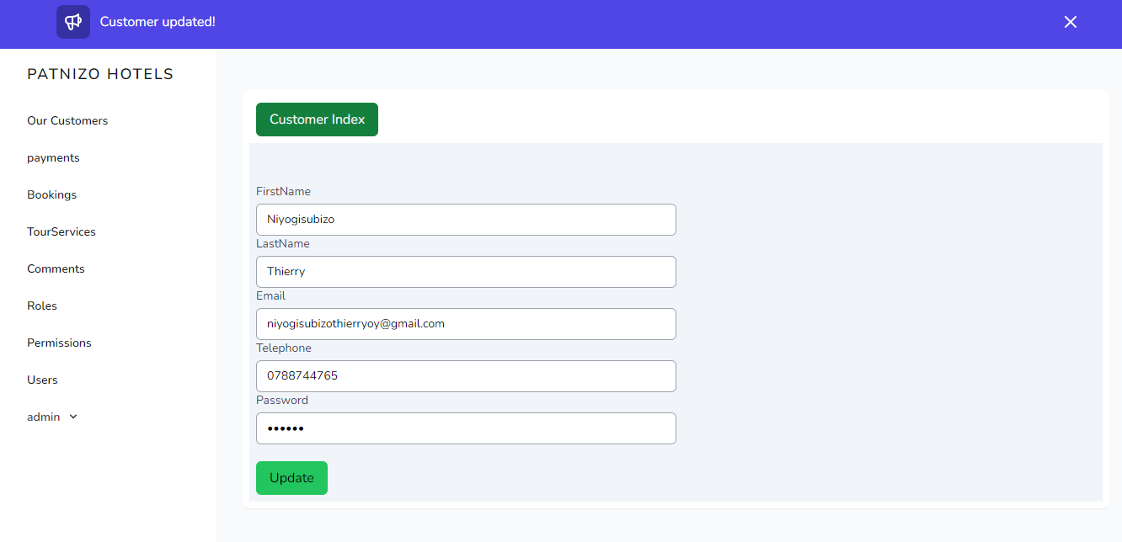

Figure 28-updated notification

Let’s check the result, click customer index above

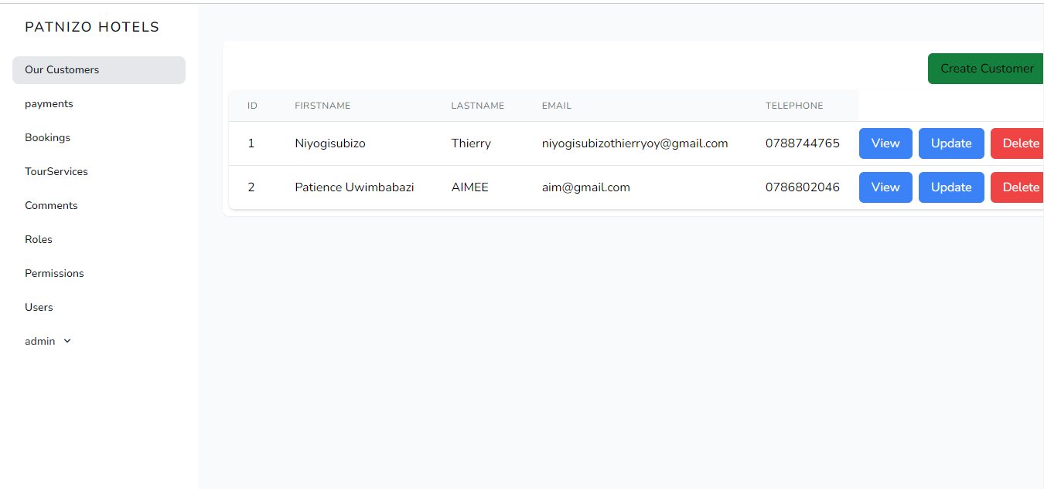

Figure 29-finally updated field

**Delete**: Lets delete the customer

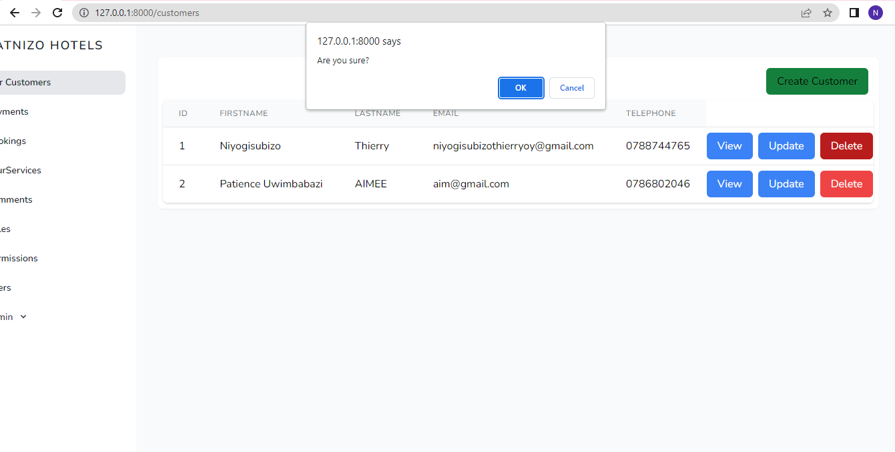

Figure 30-deleting customer

Choose Ok the Customer with Id 1will be deleted

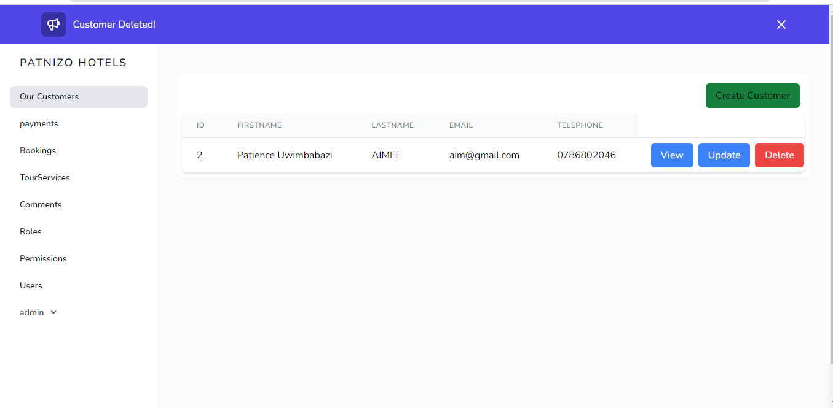

Figure 31-final deleted customer

Same Operations can be done on payments, Bookings, Tour services and Comments

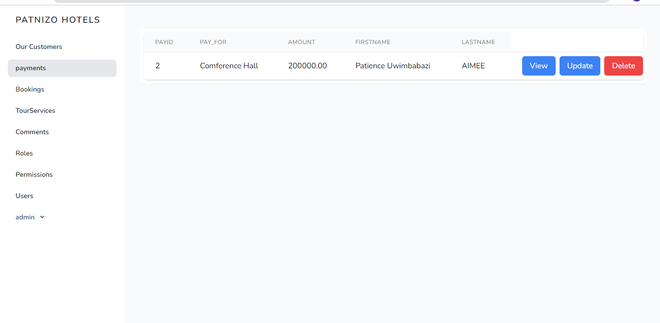

Figure 32-payment fetching names due to relationship

Let’s proceed on users

**USERS:** there are three users Admin, Worker and Viewer. These users will have different permissions but for the admin he can assign roles to other remaining users

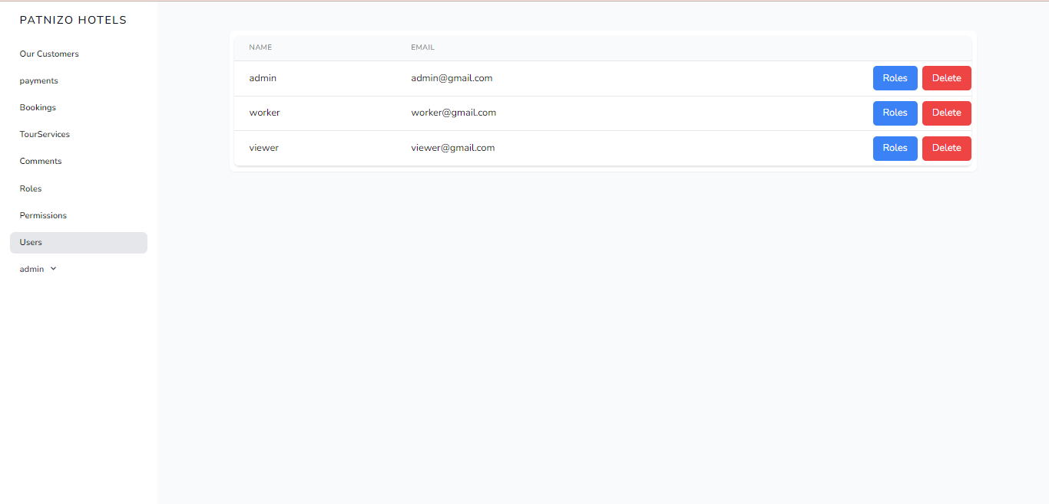

Figure 33-our users

**Roles:** we have three roles also to make it simple we used the same names, UserAdmin has a role Admin same with worker and viewer respectively.

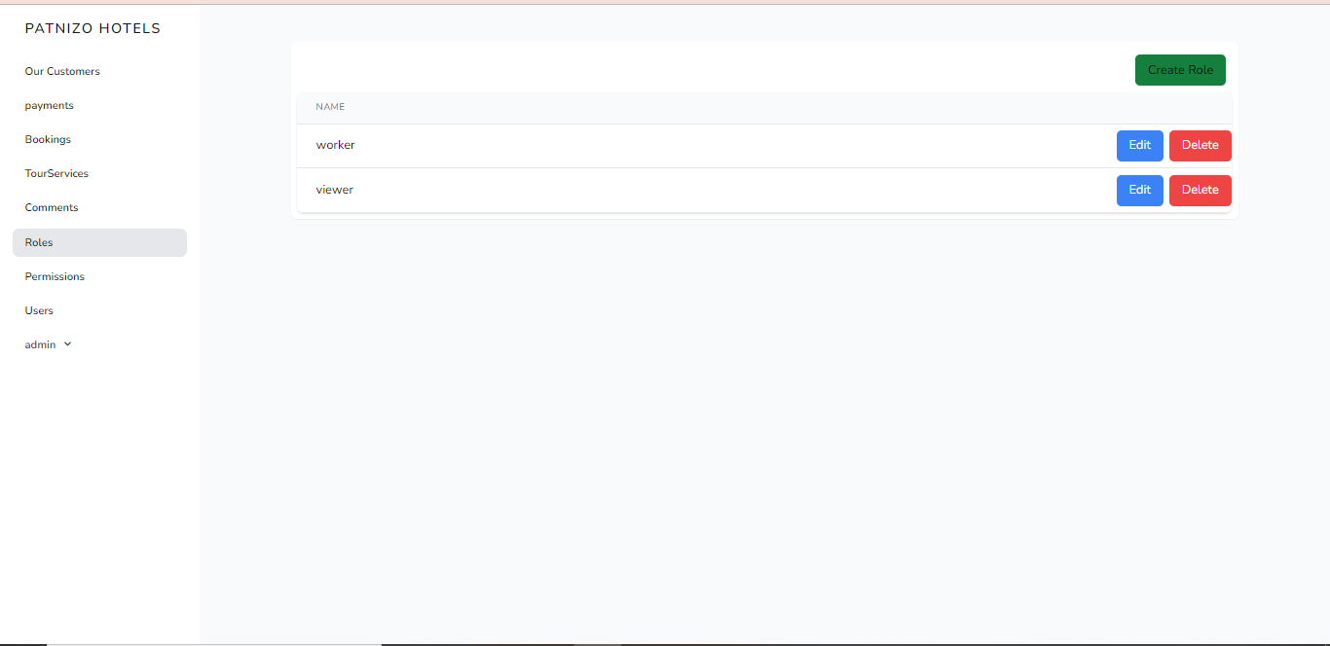

Figure 34-Roles

You can create role and edit them lets assign roles to users 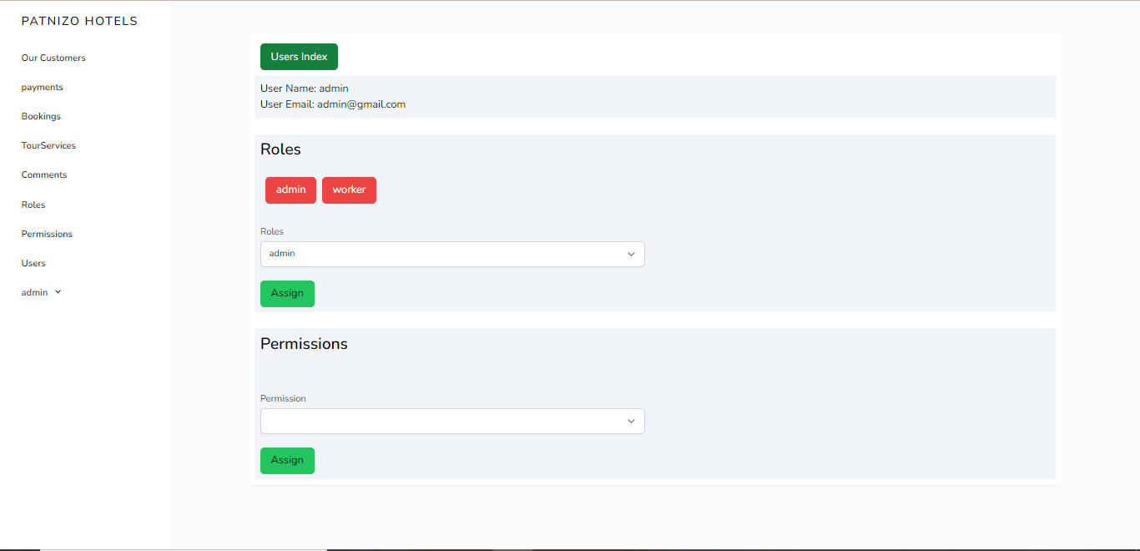

Figure 35-creating and editing roles

We can clearly see that Admin has admin and worker role lets assign him a viewer role also.

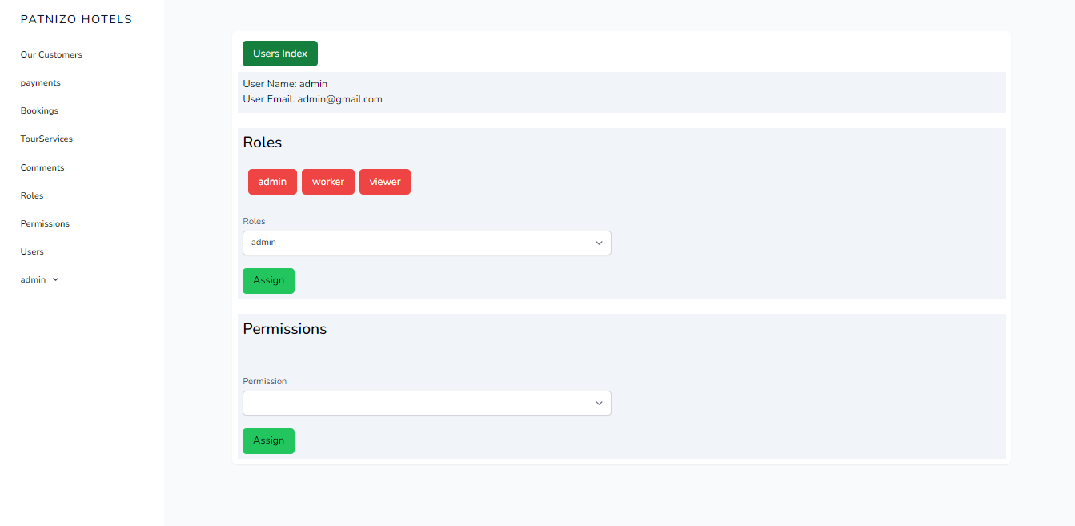

Figure 36-assigning Roles

**Assigning Permissions:** let’s give our admin 3 permissions

Manage_items, Manage_users and View_items

Got to permissions and select them.

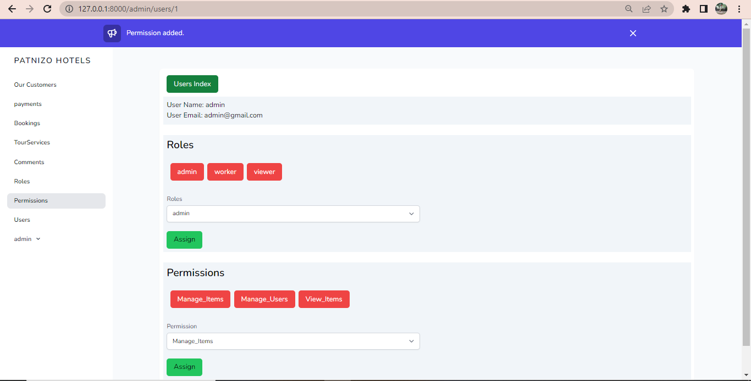

Figure 37-Assigning permissions

So the admin has full permissions

# Chapter 4. Conclusion

All in all this is patnizo Hotels project it is not completed, the implementation of the objectives of this project is at approximately 47 % the remaining 53% we are still working on them. The project is now ready to help viewer for every his or her question. And also, it allows admin to add workers, Delete, update and view (Manage items, Manage users and View items).

It also allow admin to offer permission to the worker as well as Viewer so he or she can do what is recommended.

Probably I a month the system will be ready for all customer services that are yet to be implemented as well as worker services.

Success in management requires learning as fast as the world is changing. One said that good management is the art of making problems so interesting and their solutions so constructive that everyone wants to get to work and deal with them. By patnizo Hotels we have better management and with better management we have life.

End